#include <iostream>
#include <string>
using namespace std;
//first i made a structure
struct Bankaccount {
string accnt_holder_name;
float balance;
int acccnnumber;
string acccnt_type;
float intrst_rate; // applicable only for Savings accounts
};
int accountcapcty= 0; //this is use for to show initialy it is zero
int accountCount = 0;
Bankaccount* accounts;
//i use this function to resize the account array means number of accounts which i enter in program
void accountarrayresize() {
if (accountCount >= accountcapcty) {
//i use Ternary Operator for short method instead of if else
int newcapcty = (accountcapcty== 0) ? 1 : accountcapcty* 2;
Bankaccount* newaccnts = new Bankaccount[newcapcty];
for (int i = 0; i < accountCount; i++) {
newaccnts[i] = accounts[i];
}
delete[] accounts;
accounts = newaccnts;
accountcapcty= newcapcty;
}
}
//this function is use for add new account and store member information
void addnewaccnt() {
accountarrayresize();

Bankaccount newaccnt; //acces structure information
//memeber deatails entry
cout << "Enter Account Holder Name: ";
cin >>ws; // name enter
getline (cin,newaccnt.accnt_holder_name);
cout<< "Enter Account Number: ";
cin >> newaccnt.acccnnumber;
cout << "Enter Initial Balance: ";
cin >> newaccnt.balance;
cout << "Enter Account Type (Savings/Checking): ";
cin >>ws;
getline (cin, newaccnt.acccnt_type);
cout<<endl;
//use this condition to calculte interest rates
if (newaccnt.acccnt_type == "Savings") {
cout << "Enter Interest Rate: ";
cin >> newaccnt.intrst_rate;
} else {
newaccnt.intrst_rate = 0.0;
}
//this is i use for count number of accounts how many enter there
accounts[accountCount++] = newaccnt;
cout << "Account created successfully!" << endl;
}

//this function is used fr deposit money

void depositmoney(int acccnnumber, float amt) {
//i use a coondition for calculation depsoit money
for (int i = 0; i < accountCount; i++) {
if (accounts[i].acccnnumber == acccnnumber) {
accounts[i].balance += amt;
cout << "Deposit successful! New balance: $" << accounts[i].balance << endl;
return;
}
}
//if id not found then this shows
cout << "Account not found!" << endl;
}

//show account details by its id this function is used for this purpose
void showaccount(int acccnnumber) {
for (int i = 0; i < accountCount; ++i) {
//use this condion for check id is availbe or nott
if (accounts[i].acccnnumber == acccnnumber) {
//show detail of memebr
cout << "Account Holder Name: " << accounts[i].accnt_holder_name << endl;
cout << "Account Number: " << accounts[i].acccnnumber << endl;
cout << "Balance: $" << accounts[i].balance << endl;
cout << "Account Type: " << accounts[i].acccnt_type << endl;
if (accounts[i].acccnt_type == "Savings") {
cout << "Interest Rate: " << accounts[i].intrst_rate << "%" << endl;
}
return;
}
}
//if not availbele then this show
cout << "Account not found!" << endl;
}
//this function use for calculation of transfer money
void transfermoney(int fromacccnnumber, int toacccnnumber, float amt) {
int strtindex = -1, endindex = -1;//this is used for indexeschecking
for (int i = 0; i < accountCount; i++) {
if (accounts[i].acccnnumber == fromacccnnumber) {
strtindex = i;//if accountnumber match theeen start
}
if (accounts[i].acccnnumber == toacccnnumber) {
endindex = i;
}
}//use condition for check account index array
if (strtindex == -1 || endindex == -1) {
cout << "One or both accounts not found!" << endl;
return;
}//calclute money when it add,substraction,or big it
if (accounts[strtindex].balance >= amt) {
accounts[strtindex].balance -= amt;
accounts[endindex].balance += amt;
cout << "Transfer successful!" << endl;
} else {//if not balance avilbe
cout << "Insufficient balance in source account!" << endl;
}
}
//this function use for money with draw
void moneywithdraw(int acccnnumber, float amt) {
for (int i = 0; i < accountCount; i++) {
if (accounts[i].acccnnumber == acccnnumber) {
//calclute money when it add,substraction,or big it
if (accounts[i].balance >= amt) {
accounts[i].balance -= amt;
cout << "Withdrawal successful! New balance: $" << accounts[i].balance << endl;
} else {//if not balance avilbe
cout << "Insufficient balance!" << endl;
}
return;
}
}
cout << "Account not found!" << endl;
}

//this function delete account by using backspace method
void deleteaccount(int acccnnumber) { //acesss acctnumber
for (int i = 0; i < accountCount; i++) {
//condion checks if account number equals
if (accounts[i].acccnnumber == acccnnumber) {
//the loop starts
for (int j = i; j < accountCount - 1; ++j) {
accounts[j] = accounts[j + 1];
}
accountCount--;//minus 1 account use this
cout << "Account closed successfully!" << endl;
return;
}
}
cout << "Account not found!" << endl;
}
//this funnctionc alculate interest
void calculateinterest() {
for (int i = 0; i < accountCount; i++) {
if (accounts[i].acccnt_type == "Savings") {
float interest = accounts[i].balance * (accounts[i].intrst_rate / 100);//formula to calcluate interest
accounts[i].balance += interest;
cout << "Interest added to account " << accounts[i].acccnnumber << ": $" << interest << endl;
}
}
}
//thsi function use for show all acoounts which are enter
void showaccounts() {
//if non account enter the this condition run
if (accountCount == 0) {
cout << "No accounts to display." << endl;
return;
}
//if it found accounts then it shows all accounts
for (int i = 0; i < accountCount; i++) {
//account holder deatalils
cout << "Account Holder Name: " << accounts[i].accnt_holder_name << endl;
cout << "Account Number: " << accounts[i].acccnnumber << endl;
cout << "Balance: $" << accounts[i].balance << endl;
cout << "Account Type: " << accounts[i].acccnt_type << endl;//calculation of interests and condition check
if (accounts[i].acccnt_type == "Savings") {
cout << "Interest Rate: " << accounts[i].intrst_rate << "%" << endl;
}

}
}
//main function
int main() {
int n;//input n varible
//use loop to cehck conditions until
while (true) {
cout << "1. Create a new account" << endl;
cout << "2. View account" << endl;
cout << "3. Deposit money" << endl;
cout << "4. Withdraw money" << endl;
cout << "5. Transfer money between accounts" << endl;
cout << "6. show all accounts" << endl;
cout << "7. Calculate interest for Savings accounts" << endl;
cout << "8. Close an account" << endl;
cout << "9. Exit" << endl;
cout << "Enter your number choice: ";
cin >> n;

int acccnnumber, toacccnnumber;
float amt; //use switch condition and call functions
switch (n) {
case 1:
addnewaccnt();
break;
case 2:
cout << "Enter your account number: ";
cin >> acccnnumber;
showaccount(acccnnumber);
break;
case 3:
cout << "Enter account number: ";
cin >> acccnnumber;
cout << "Enter amt to deposit: ";
cin >> amt;
depositmoney(acccnnumber, amt);
break;
case 4:
cout << "Enter your account number: ";
cin >> acccnnumber;
cout << "Enter amountt you want to withdraw: ";
cin >> amt;
moneywithdraw(acccnnumber, amt);
break;
case 5:
cout << "Enter your now account number: ";
cin >> acccnnumber;
cout << "Enter yourdestination account number: ";
cin >> toacccnnumber;
cout << "Enter amountt which you want to transfer: ";
cin >> amt;
transfermoney(acccnnumber, toacccnnumber, amt);
break;
case 6:
showaccounts();
break;
case 7:
calculateinterest();
break;
case 8:
cout << "Enter your account number to close: ";
cin >> acccnnumber;
deleteaccount(acccnnumber);
break;
case 9:
cout << "Program Exit" << endl;

default:
cout << "Invalid n! Please try again." << endl;
}
cout << endl;
}
}

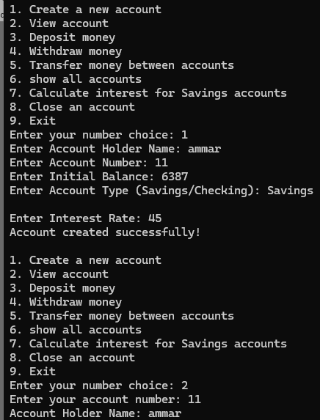
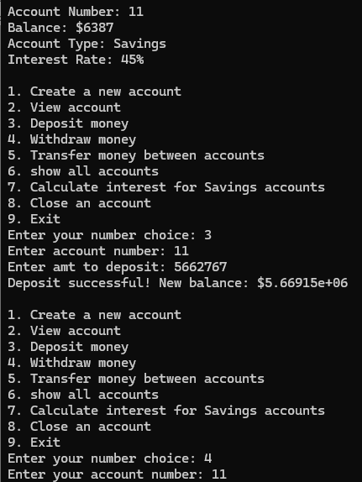
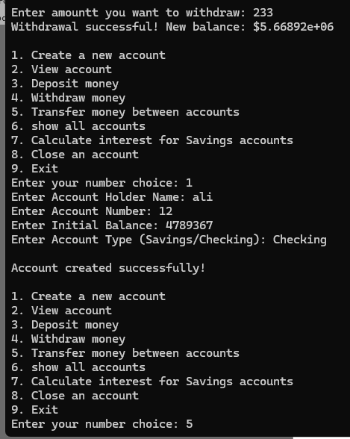
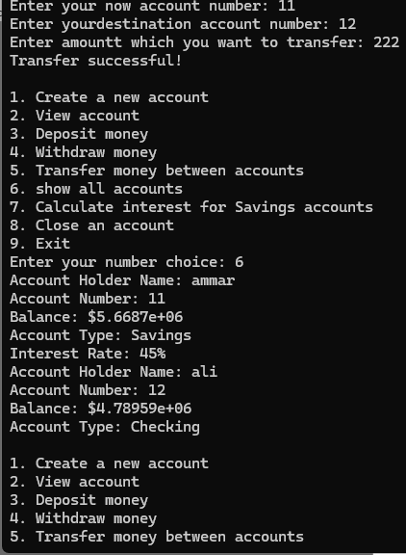
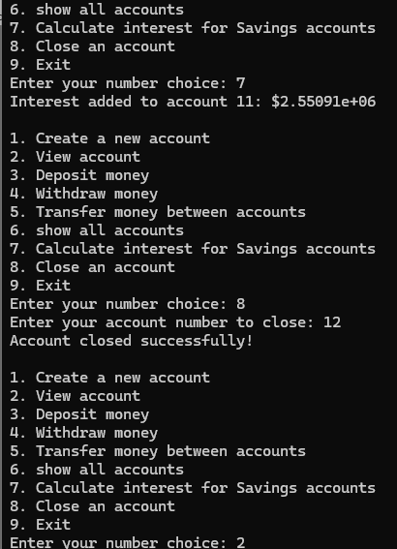
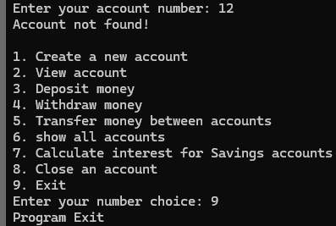
Conclusion:
I made a bank management sytum using functions and structure. This is a easy understandable system which I made by my hand or brain. I research on it some but made by myself.

